

S3 and Glacier Assignment

Virtualization and Cloud Computing



March 16, 2020

Submitted BY: M. Iftikhar Uddin Khan Sami

022-16-113275

S3 and Glacier Assignment

In this class, we will compare Amazon S3 with other leading cloud service provider.

### Identify any five leading cloud computing providers.

* [Amazon Web Services](https://aws.amazon.com/)
* [Microsoft Azure](https://azure.microsoft.com/en-in/)
* [Google Cloud Platform](https://cloud.google.com/)
* [VMware](http://www.vmware.com/in/cloud-services/infrastructure.html)
* [SAP](https://www.sap.com/solution/cloud.html)
* [Dropbox](https://www.dropbox.com/business/)

### Find out any service provided by each of the provider closest / similar to Amazon S3.

**Google Cloud Storage** is a [RESTful](https://en.wikipedia.org/wiki/Representational_state_transfer) online file storage web service for storing and accessing data on Google Cloud Platform infrastructure. The service combines the performance and scalability of Google's cloud with advanced security and sharing capabilities. It is an *Infrastructure as a Service (IaaS)*, comparable to **Amazon S3** online storage service. Contrary to Google Drive and according to different service specifications, Google Cloud Storage appears to be more suitable for enterprises.

### What are the pricing options?

The system works on the model of **Pay as you go** with no

[Google Drive pricing](https://one.google.com/about)

[G Suite pricing](https://gsuite.google.com/pricing.html?_ga=2.175288674.1731857457.1584363259-136365247.1580727149)

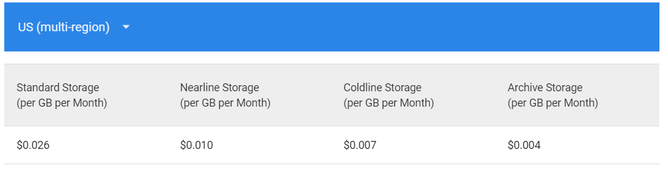

Figure 1- <https://cloud.google.com/storage/pricing#price-tables>

Reference: <https://cloud.google.com/pricing>

### Do they support object based [storage](http://vle.iuk.edu.pk/moodle/mod/resource/view.php?id=38121)? Do they provide various service classes? Do they support versioning? Do they support life cycle management?

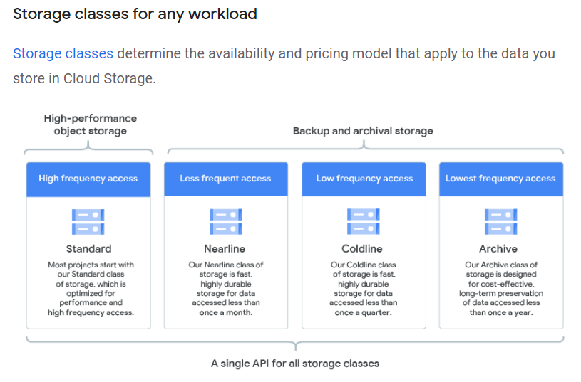

Storage Classes: <https://cloud.google.com/storage/docs/storage-classes>

**Available Storage** [**Classes**](https://cloud.google.com/storage/docs/storage-classes#available_storage_classes)**:**

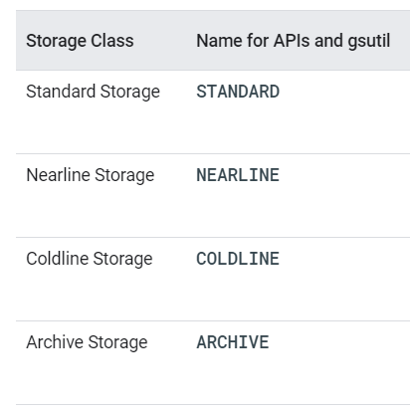

Google Cloud supports [Versioning](https://cloud.google.com/storage/docs/storage-classes#available_storage_classes).

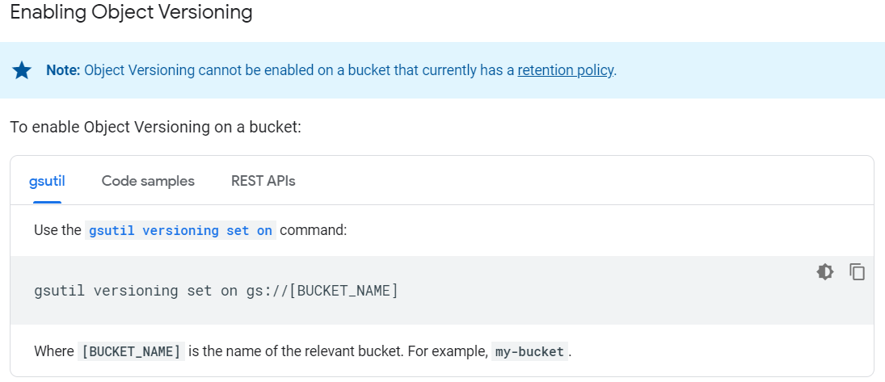

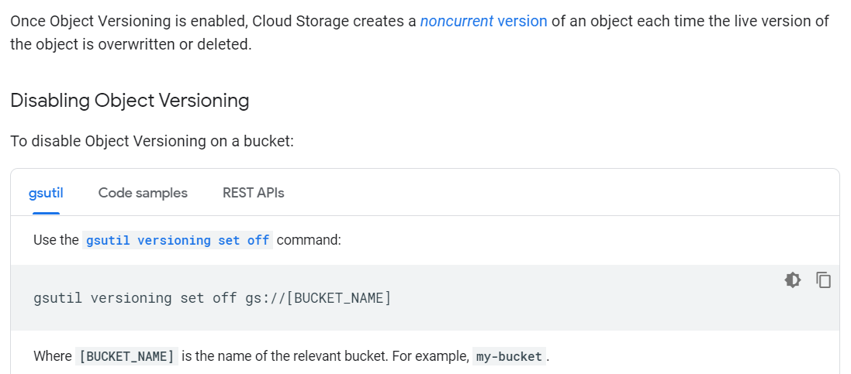

Google Cloud supports [Lifecycle Management](https://cloud.google.com/storage/docs/lifecycle).

**Introduction**

You can assign a lifecycle management configuration to a bucket. The configuration contains a set of rules which apply to current and future objects in the bucket. When an object meets the criteria of one of the rules, Cloud Storage automatically performs a specified action on the object. Here are some example use cases:

* Downgrade the storage class of objects older than 365 days to Coldline Storage.
* Delete objects created before January 1, 2013.
* Keep only the 3 most recent versions of each object in a bucket with versioning enabled.

**Lifecycle configuration**

Each lifecycle management configuration contains a set of rules. When defining a rule, you can specify any set of conditions for any action. If you specify multiple conditions in a rule, an object has to match all of the conditions for the action to be taken. If you specify multiple rules that contain the same action, the action is taken when an object matches the condition(s) in any of the rules. Each rule should contain only one action.

If multiple rules have their conditions satisfied simultaneously for a single object, Cloud Storage performs the action associated with only one of the rules, based on the following considerations:

* The Delete action takes precedence over any SetStorageClass action.
* The SetStorageClass action that switches the object to the storage class with the lowest at-rest storage pricing takes precedence.

Once an action occurs, the object is re-evaluated before any additional actions are taken.

So, for example, if you have one rule that deletes an object and another rule that changes the object's storage class, but both rules use the exact same condition, the delete action always occurs when the condition is met. If you have one rule that changes the object's class to Nearline Storage and another rule that changes the object's class to Coldline Storage, but both rules use the exact same condition, the object's class always changes to Coldline Storage when the condition is met.

**Draw a table comparing the AWS and your selected cloud providers.**

|  |  |  |  |  |
| --- | --- | --- | --- | --- |
|  | Amazon Web Services | | Google Cloud | |
| Introduction | Amazon Web Services (AWS) is a subsidiary of Amazon that provides on-demand cloud computing platforms and APIs to individuals, companies, and governments, on a metered pay-as-you-go basis. In aggregate, these cloud computing web services provide a set of primitive abstract technical infrastructure and distributed computing building blocks and tools. One of these services is Amazon Elastic Compute Cloud, which allows users to have at their disposal a virtual cluster of computers, available all the time, through the Internet. AWS's version of virtual computers emulate most of the attributes of a real computer, including hardware central processing units (CPUs) and graphics processing units (GPUs) for processing; local/RAM memory; hard-disk/SSD storage; a choice of operating systems; networking; and pre-loaded application software such as web servers, databases, and customer relationship management (CRM) | Google Cloud Platform (GCP), offered by Google, is a suite of cloud computing services that runs on the same infrastructure that Google uses internally for its end-user products, such as Google Search, Gmail and YouTube. Alongside a set of management tools, it provides a series of modular cloud services including computing, data storage, data analytics and machine learning. Registration requires a credit card or bank account details. | |
| Pricing | It supports Pricing | | It supports Pricing | |
| Versioning | It supports Versioning | | It supports Versioning | |
| Lifecycle Management | It supports Lifecycle Management | | It supports Lifecycle Management | |
| Object Based Storage | It supports Object Based Storage | | It supports Object Based Storage | |
| URL | <https://aws.amazon.com/> | | <https://cloud.google.com/> | |